DREAMWEAVER E-PROJECT

 AUTO WORLD.COM

USER’S MANUAL

**GROUP MEMBERS SUBMITTED TO**

**Muneeb Farid Sheikh (Group Leader)** [eProjects@aptechfze.ae](mailto:eProjects@aptechfze.ae)

**Student**  **PROJECT INSTRUCTOR**

**Syed Zohaib Ali**  **Miss Mehneemah shafi**

**Student** **CURRICULLUM CODE**

**Syed Daniyal Ali**  **6673**

**Student**

**Muhammad Usama**

**Student**

 AUTO WORLD.COM

**TABLE OF CONTENTS**

ACKNOWLEGDMENT --------------------------------------------------------------------------3

PROJECT CRETIFICATION----------------------------------------------------------------------4

INTRODUCTION TO AUTO WORLD----------------------------------------------------------5

REQUIRMENT SPECIFICATION----------------------------------------------------------------6

(A) HARDWERE REQUIRMENT---------------------------------------------------------------7

(B) SOFTWERE REQUIRMENT---------------------------------------------------------------8

PROJECT DURATION----------------------------------------------------------------------------9

TASK SHEET---------------------------------------------------------------------------------------10

SNAPSHOT-----------------------------------------------------------------------------------------11

## **Auto World Home Page**



Navbar

Carousel

## **Models**

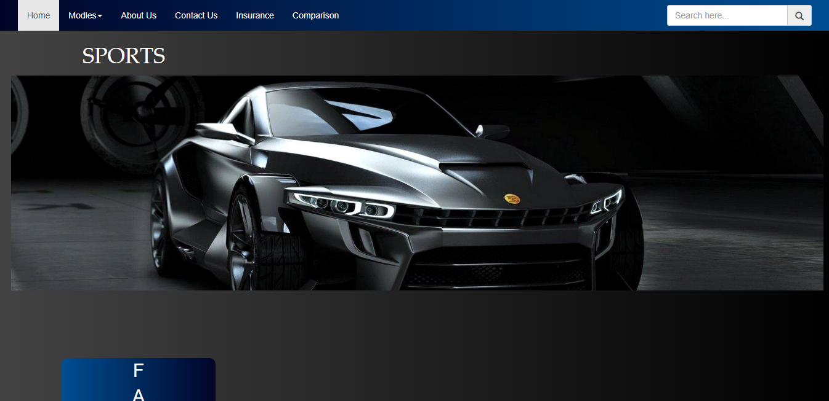

Upon Clicking Models You will navigate to Categories

## **Models Categories**

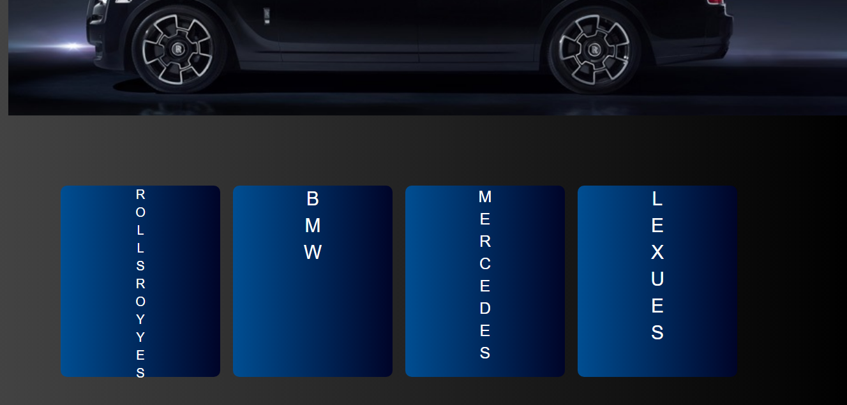

Click Categories to see further models.

## **Cars**

For Specifications of cars Click on the name of that car.

## **Specifications of Car Models**

## 

## **Insurance Schemes**

Click Read More Button to find out more.

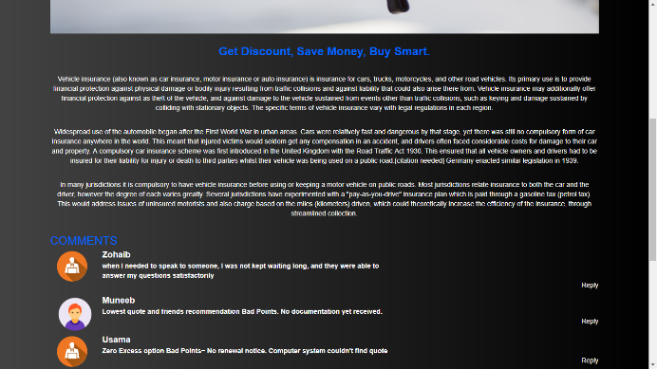

## **Comparison**

1. Select Model A

2. Click Compare A Button

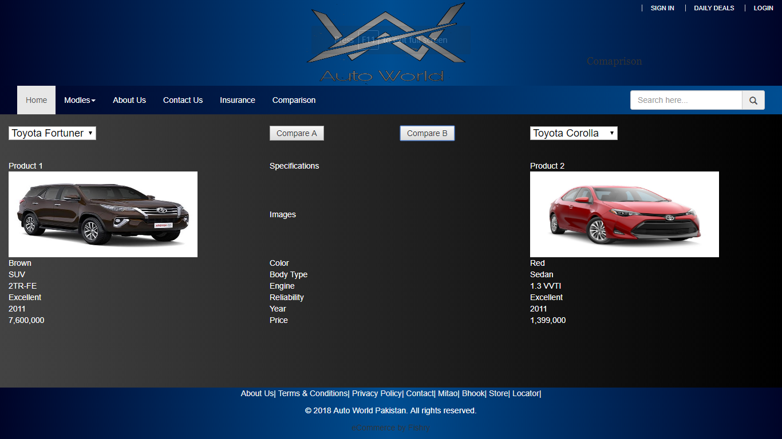

Follow the same procedure for the second model.

## **Sign Up And Log In**

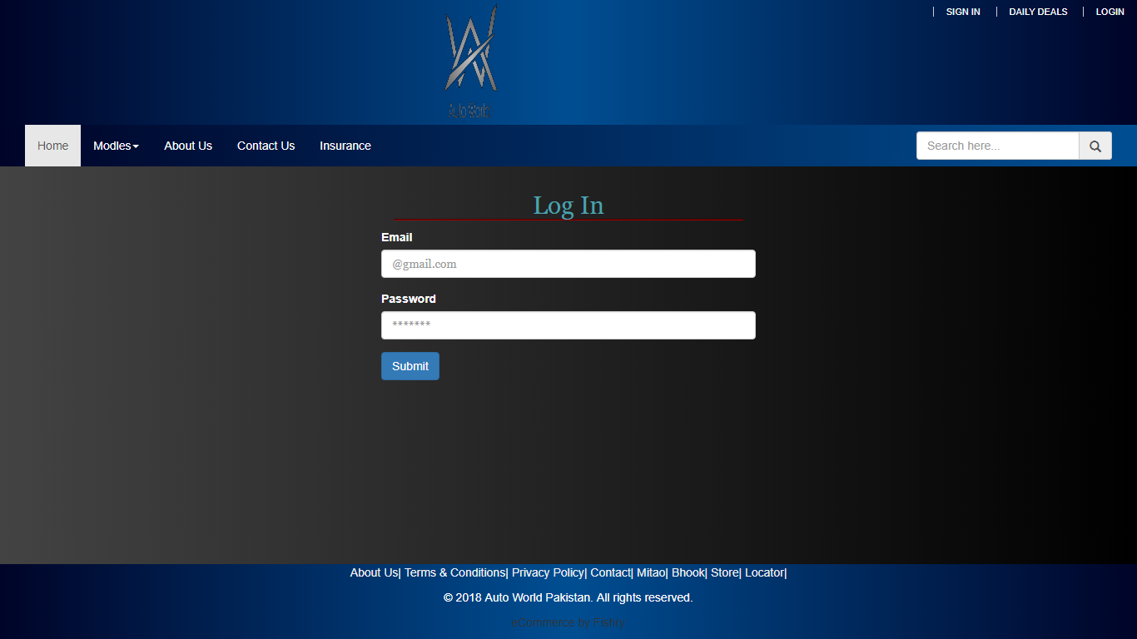

## **Contact Us**

